# **Chapter 1 Lab**

## Part 1:

**Important:** Once your program is completed and runs, copy the code into a text file with the same name as the program and submit it in this assignment.

1. Open Eclipse and start a new Java project named **Lab1A**, and a new class named **Lab1A**

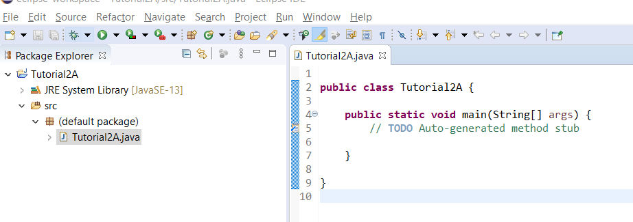

1. Delete the comment on line 5; we will start our program code there.
2. Declare 3 integer variables: **num1=50**, **num2=20** and **answer** on line 5.
3. Print a row of 10 back slashes (\) and 10 forward slashes (/). Remember, that you have to use the escape code \\ to print 1 back slash, so your statement will be: System.out.println("\\\\\\\\\\\\\\\\\\\\//////////");

(You must print 20 \ to make 10 appear because of the escape code rules, but you can print / normally.)

1. Set **answer** equal to **num1** + **num2 - 5**
2. Print the following: "num1 + num2 - 5" = **answer**. You should include the quotation marks and have a tab between the = and **answer**.

Do this by typing: **System.out.println(" \"num1 + num2 - 5\" = \t" + answer);**

(Each \" will cause a quotation mark to be printed on the output screen and \t will insert a tab.)

1. Repeat step 5 to print the row of \\\\\\\\\\////////// again.
2. At the top of your program insert comments in the following format:

**// Program Name:** program name here **// Name:** your name here **// Purpose:** A sentence that describes what this program is doing. (For this one you can say that we’re practicing math and escape codes or something like that.)

You will need to include these 3 lines at the top of every program you turn in.

## Part 2:

**Important: Make sure you include the 3 line headers described above in both of these programs too; otherwise you will lose points.**

1. Write a Java project called **Lab1B** that declares 3 integers: **side, perimeter & area**

Set **side** equal to 100  
Set **perimeter** and **area** by calculating their value based on **side**. (perimeter is 4 * side, area is side2)  
Then print all 3 values, using a label in front of each one. A label is a descriptive word in quotes that tells the user what they are looking at. The output for this program should be:

Side is 100

Perimeter is 400

Area is 10000

But make sure you are printing the variables in your System.out.println statements, not just the numbers I showed.

1. Write a Java project called **Lab1C** that declares two doubles: **num1** and **num2**

Also declare 3 other double variables: **sum**, **diff** and **product**

Set **num1** and **num2** to equal 57 and 13.

Calculate the values of **sum, diff** (the difference between the two)**,** and **product** (the two multiplied together)**.**

Print the numbers themselves, and then print their sum, difference and product. (Use a label for each one.)